**MODULE 3- DATABASE ESSENTIALS**

**WORK WITH DATABASES**

[**ALL ABOUT DATABASES**](https://www.coursera.org/learn/data-preparation/lecture/szLl7/all-about-databases)

Next step, we're going to learn all about databases. As a refresher, a **database is a collection of data stored in a computer system, but storage is just the beginning**. You'll discover how databases make it possible to find the exact piece of information you need for your analysis. You'll also learn how to **sort data** in order to zoom in on what you need to generate insightful reports and much more. Then we'll go even deeper, and I mean really, really deep. I'm talking about **metadata**. You've probably heard someone say, wow that's so meta. **Usually they're talking about something referencing back to itself or being completely self aware**. For example if a character in a book knows she's in a book, that's meta. If you make a documentary about making documentaries, that's also meta. And here at Google, I constantly analyze how I analyze data. That's definitely meta.

I do that to give my work a quality check to make sure my methods are fair. And to be certain that I'm paying attention to any biases that might affect the outcome. As an analyst, you should do this too. Sometimes we get a little too close to our data. So stepping back and asking ourselves if our processes make sense is key. But let's back up just a bit and define metadata. **Metadata is data about data**. Like I said: deep.

**Metadata is extremely important when working with databases**. Think of it like a reference guide. Without the guide all you have is a bunch of data with no context explaining what it means. Metadata tells you where the data comes from, when and how it was created, and what it's all about.

Up next, you'll learn how to take data from a database or another source and bring it into a spreadsheet. You'll do this either by importing it directly or by using SQL to generate the request. And once you have data in a spreadsheet, the possibilities are endless. Everything we're about to cover is a very important part of the Prepare phase of the data analysis process. It's how data analysts figure out which kind of data is going to be most helpful to them. If you have the right data, you're much more likely to be able to solve your business problems successfully.

[**DATABASE FEATURES AND COMPONENTS**](https://www.coursera.org/learn/data-preparation/lecture/JCWIr/database-features-and-components)

**Databases** are essential tools for data analysts. I use them constantly. Just about all of the data I access is stored within databases. Databases store and organize data, making it much easier for data analysts to manage and access information. They help us get insights faster, make data-driven decisions, and solve problems. You've already heard a bit about what databases are and how they're used by data analysts.

Now let's learn more about database features and components. Here's a simple database structure.

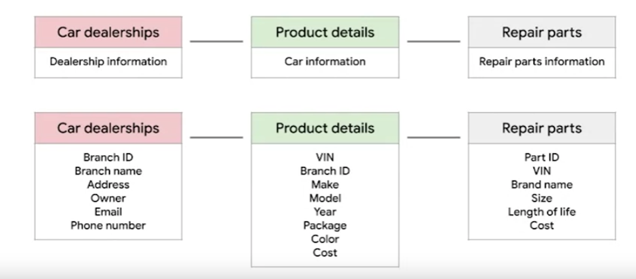

It contains tables with information from a car manufacturer. The top level includes car dealerships, product details, and repair parts. Then if you drill down to the next level by selecting one of those tables, you'll find more specific details about each item. This is called a **relational database**.

A relational database is a **database that contains a series of related tables that can be connected via their relationships**. For two tables to have a relationship, one or more of the same fields must exist inside both tables.

For example, here, **branch ID exists in this table and this one. If a field exists within both tables, we can use it to connect the tables together. The branch ID field is the key to connecting these tables.**

There are two types of keys.

A **primary key** **is an identifier that references a column in which each value is unique**. **You can think of it as a unique identifier for each row in a table**. For our dealership table with information about the different dealership branches, branch ID is the primary key. Similarly, for the product details table about each car, **VIN is our primary key**. As an analyst you may need to create tables. If you do decide to include **a primary key, it should be unique, meaning no two rows can have the same primary key. Also, it cannot be null or blank.**

**There are also foreign keys**. A foreign key **is a field within a table that's a primary key in another table**. In other words, **a foreign key is how one table can be connected to another**. Because our repair parts table contains information about each car part, the primary key is part ID. Each row in our repair parts table represents one unique part. All the other keys in this table, such as the VIN, are the foreign keys that allow the repair parts table to be connected to the other tables. **A table can only have one primary key but it can have multiple foreign keys.**

**As a general summary**, **a primary key is used to ensure data in a specific column is unique**. It uniquely identifies a record in a relational database table.

**Only one primary key is allowed in a table and they cannot contain null or blank values**.

**A foreign key is a column or group of columns in a relational database table that provides a link between the data and two tables**. It refers to the field in a table that's the primary key of another table.

Lastly, **it's important to note that more than one foreign key is allowed to exist in a table.**

Feel free to rewatch this video to be sure you understand primary and foreign keys clearly. And coming up, you'll begin practicing how to access and analyze data from actual databases. That will be a great opportunity to improve your understanding of primary and foreign keys, database organization and how you might use databases in your future analytics career.

[**MAXIMIZE DATABASES IN DATA ANALYTICS**](https://www.coursera.org/learn/data-preparation/supplement/uXqEX/maximize-databases-in-data-analytics)

**Databases enable analysts to manipulate, store, and process data.** This helps them search through data a lot more efficiently to get the best insights.



## **Relational databases**

A **relational database** is a database that contains a series of tables that can be connected to form relationships. Basically, they allow data analysts to organize and link data based on what the data has in common.

In a non-relational table, you will find all of the possible variables you might be interested in analyzing all grouped together. This can make it really hard to sort through. **This is one reason why relational databases are so common in data analysis:** they simplify a lot of analysis processes and make data easier to find and use across an entire database.

**Normalization** is a process of organizing data in a relational database. For example, creating tables and establishing relationships between those tables. **It is applied to eliminate data redundancy, increase data integrity, and reduce complexity in a database.**

## **The key to relational databases**

Tables in a relational database are connected by the fields they have in common. You might remember learning about primary and foreign keys before. As a quick refresher, a **primary key** is an identifier that references a column in which each value is unique. In other words, it's a column of a table that is used to uniquely identify each record within that table. The value assigned to the primary key in a particular row must be unique within the entire table. For example, if customer_id is the primary key for the customer table, no two customers will ever have the same customer_id.

By contrast, a **foreign key** is a field within a table that is a primary key in another table. A table can have only one primary key, but it can have multiple foreign keys. These keys are what create the relationships between tables in a relational database, which helps organize and connect data across multiple tables in the database.

**Some tables don't require a primary key. For example, a revenue table can have multiple foreign keys and not have a primary key.**

**A primary key may also be constructed using multiple columns of a table**. This type of primary key is called a **composite key**. For example, if customer_id and location_id are two columns of a composite key for a customer table, the values assigned to those fields in any given row must be unique within the entire table.

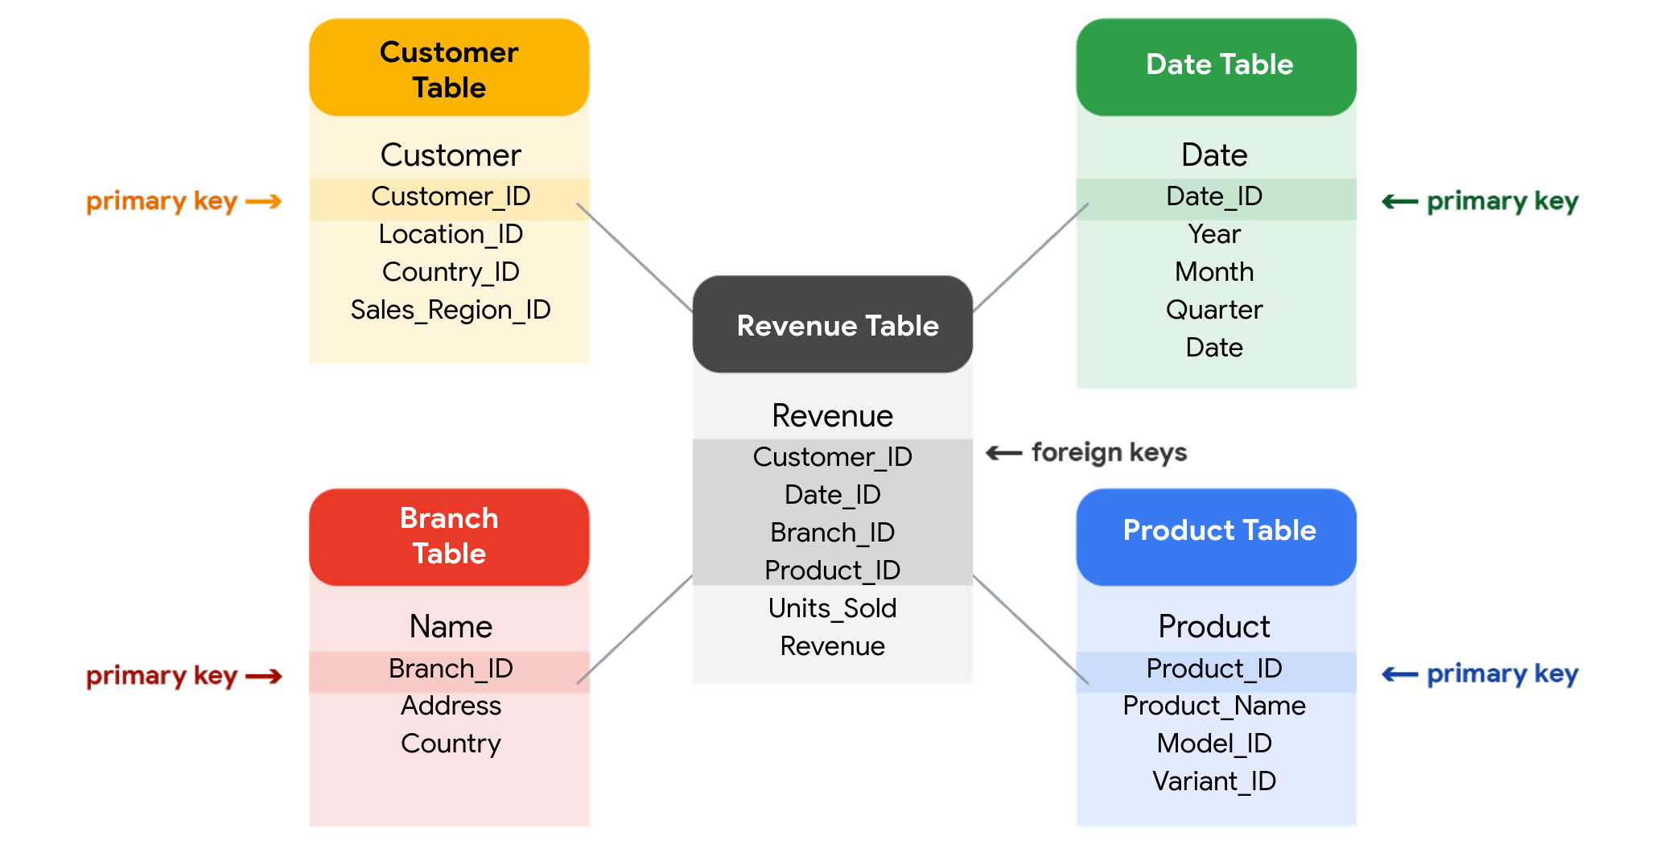

## **SQL? You’re speaking my language**

As you've been learning, **Structured Query Language** (SQL) **is a type of query language that enables data analysts to communicate with a database**. So, a data analyst will use SQL to create a query to view the specific data that they want from within a larger dataset. In a relational database, data analysts can write queries to get data from the related tables. SQL is a powerful tool for working with databases—which is why you are going to learn more about it coming up!

[**INSPECT A DATASET: A GUIDED, HANDS-ON TOUR**](https://www.coursera.org/learn/data-preparation/supplement/0FIHG/inspect-a-dataset-a-guided-hands-on-tour)

As a data analyst, you'll use data to answer questions and solve problems. When you analyze data and draw conclusions, you are generating insights that can influence business decisions, drive positive change, and help your stakeholders meet their goals.

Before you begin an analysis, it’s important to inspect your data to determine if it contains the specific information you need to answer your stakeholders’ questions. In any given dataset, it may be the case that:

* The data is not there (you have sandwich data, but you need pizza data)
* The data is insufficient (you have pizza data for June 1-7, but you need data for the entire month of June)
* The data is incorrect (your pizza data lists the cost of a slice as $250, which makes you question the validity of the dataset)

Inspecting your dataset will help you pinpoint what questions are answerable and what data is still missing. You may be able to recover this data from an external source or at least recommend to your stakeholders that another data source be used.

In this reading, imagine you’re a data analyst inspecting spreadsheet data to determine if it’s possible to answer your stakeholders’ questions.

## 

## **The scenario**

You are a data analyst working for an ice cream company. Management is interested in improving the company's ice cream sales.

The company has been collecting data about its sales—but not a lot. The available data is from an internal data source and is based on sales for 2019. You’ve been asked to review the data and provide some insight into the company’s ice cream sales. Ideally, management would like answers to the following questions:

1. What is the most popular flavor of ice cream?
2. How does temperature affect sales?
3. How do weekends and holidays affect sales?
4. How does profitability differ for new versus returning customers?

## **Download the data**

You can download the data to follow along with this reading. To use the template for the sales data, click the link below and select “Use Template.”

Link to template: [Ice Cream Sales](https://docs.google.com/spreadsheets/d/1NgiKb8wCnJbUTuUkDUiNRpx9NhwncEmoKuPvgfYfOIY/template/preview?resourcekey=0-X3e7NzehG2Y74MIBhOaqeQ#gid=653912415)

OR

If you don’t have a Google account, you can download the spreadsheets directly from the attachments below:

[SalesByTemp](https://d3c33hcgiwev3.cloudfront.net/jmigEulNR7yooBLpTYe8Cw_9ecaf818f1a74b7987fe6a7d9af3c1f1_SalesByTemp.xlsx?Expires=1711238400&Signature=Z4CqaxIyXW5OavHref7vuTvgXBArgO4iY7pKaRzBzBJT0Qwot26dgbLMdZhRf-bdFxtwxOff4anZanztuLxUQrOgucQrdp8Lag562PlsjOa5bjXiJn7-7Vw71LvvlxJ-e1xaXCRP~J-6atG8VYGnQdKL07aGmX4ZEouL7sJRiiA_&Key-Pair-Id=APKAJLTNE6QMUY6HBC5A)

[XLSX File](https://d3c33hcgiwev3.cloudfront.net/jmigEulNR7yooBLpTYe8Cw_9ecaf818f1a74b7987fe6a7d9af3c1f1_SalesByTemp.xlsx?Expires=1711238400&Signature=Z4CqaxIyXW5OavHref7vuTvgXBArgO4iY7pKaRzBzBJT0Qwot26dgbLMdZhRf-bdFxtwxOff4anZanztuLxUQrOgucQrdp8Lag562PlsjOa5bjXiJn7-7Vw71LvvlxJ-e1xaXCRP~J-6atG8VYGnQdKL07aGmX4ZEouL7sJRiiA_&Key-Pair-Id=APKAJLTNE6QMUY6HBC5A)

[SalesByDay](https://d3c33hcgiwev3.cloudfront.net/B3ofmLtERPq6H5i7RFT6Pg_1ca5eec9c08941518e2c16034a2e65f1_SalesByDay.xlsx?Expires=1711238400&Signature=SCHwjdKSsCIlFBag5TNW2wwnrgVGifOcVN0XsXMngSJ1BvFWkjsTwDidWXWxCWO330pr6C3qQWfxGkqT6kUbVJBu4qhk-1DRySfjDuRzZEkZXNxcZWd7b6r-VFh3DjfTb5LIjMvNmuWZDKx1U-uO12HRX2iHyJOZKRjlxdVxM8U_&Key-Pair-Id=APKAJLTNE6QMUY6HBC5A)

[XLSX File](https://d3c33hcgiwev3.cloudfront.net/B3ofmLtERPq6H5i7RFT6Pg_1ca5eec9c08941518e2c16034a2e65f1_SalesByDay.xlsx?Expires=1711238400&Signature=SCHwjdKSsCIlFBag5TNW2wwnrgVGifOcVN0XsXMngSJ1BvFWkjsTwDidWXWxCWO330pr6C3qQWfxGkqT6kUbVJBu4qhk-1DRySfjDuRzZEkZXNxcZWd7b6r-VFh3DjfTb5LIjMvNmuWZDKx1U-uO12HRX2iHyJOZKRjlxdVxM8U_&Key-Pair-Id=APKAJLTNE6QMUY6HBC5A)

[SalesByFlavor](https://d3c33hcgiwev3.cloudfront.net/DHN9hYWCSDCzfYWFgvgwgg_b0e0d35f6a4f4bde9c84ecd0dd69c0f1_SalesByFlavor.xlsx?Expires=1711238400&Signature=WmDSTTHuZBq8KHICDznaZ5hFi-wh5GQ6zpRG-6NIpK1fE5chbFe2xDFOrq4f9G9emjDsLeO6Vq8QjKk~3rT9OcCzBC1u3wqHpIXA5yL43wMfVKaBs-RC1A7JnZEEO6D5O6xAOLtdFoFDMPeTPv7qqLm2UfamWxHwtegU0ND1JLM_&Key-Pair-Id=APKAJLTNE6QMUY6HBC5A)

[XLSX File](https://d3c33hcgiwev3.cloudfront.net/DHN9hYWCSDCzfYWFgvgwgg_b0e0d35f6a4f4bde9c84ecd0dd69c0f1_SalesByFlavor.xlsx?Expires=1711238400&Signature=WmDSTTHuZBq8KHICDznaZ5hFi-wh5GQ6zpRG-6NIpK1fE5chbFe2xDFOrq4f9G9emjDsLeO6Vq8QjKk~3rT9OcCzBC1u3wqHpIXA5yL43wMfVKaBs-RC1A7JnZEEO6D5O6xAOLtdFoFDMPeTPv7qqLm2UfamWxHwtegU0ND1JLM_&Key-Pair-Id=APKAJLTNE6QMUY6HBC5A)

[](https://d3c33hcgiwev3.cloudfront.net/DHN9hYWCSDCzfYWFgvgwgg_b0e0d35f6a4f4bde9c84ecd0dd69c0f1_SalesByFlavor.xlsx?Expires=1711238400&Signature=WmDSTTHuZBq8KHICDznaZ5hFi-wh5GQ6zpRG-6NIpK1fE5chbFe2xDFOrq4f9G9emjDsLeO6Vq8QjKk~3rT9OcCzBC1u3wqHpIXA5yL43wMfVKaBs-RC1A7JnZEEO6D5O6xAOLtdFoFDMPeTPv7qqLm2UfamWxHwtegU0ND1JLM_&Key-Pair-Id=APKAJLTNE6QMUY6HBC5A)

## **Inspect the data**

### **Question 1: What is the most popular flavor of ice cream?**

To discover the most popular flavor, you first need to define what is meant by "popular." Is the most popular flavor the one that generated the most revenue in 2019? Or is it the flavor that had the largest number of units sold in 2019? Sometimes your measurement choices are limited by what data you have—you can review your spreadsheet to find out if either of these definitions of “popular” make sense based on the available data.

Click the **flavors** tab on your spreadsheet to view the relevant data. The **flavors** sheet has three columns and 209 rows of data. The column headers are **week**, **units sold***,* and **flavor**. This dataset did not come with a data description, so you have to figure out the significance of the columns on your own. Based on the data, you deduce that these columns provide information about the number of units sold for each ice cream flavor, by week, in 2019

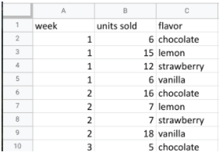

In this case, you can discover what the most popular flavor is by using units sold as your measure. In particular, you can use the **units sold** column to calculate the total number of units sold during the year for each flavor*.* Unfortunately, the dataset does not provide the annual sales amount by flavor. In this case, your next step would be to ask your stakeholders if the annual sales per flavor data is available from another source. If not, you can add a statement about the current data’s limitations to your analysis.

### **Question 2: How does temperature affect sales?**

To explore your second question, you click the **temperatures** tab and check out the data. The **temperature** sheet has two columns and 366 rows of data. The column headers are **temperature** and **sales**. The data may show total 2019 sales per temperature (for instance, the first entry might sum up $39.69 in sales for three separate days that each had a high of 60 degrees). Or, the data may show a snapshot of sales and temperature for each day in 2019 (for instance, the first entry might refer to a single day with a high of 60 degrees and $39.69 in sales).

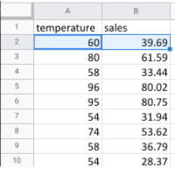

So, which is it? It’s probably a daily snapshot because there are 365 entries for temperature, and multiple rows with the same temperature and different sales values. This implies that each entry is for a single day and not a summary of multiple days. However, without more information, you can’t be certain. Plus, you don’t know if the current data is listed in consecutive order by date or in a different order. Your next step would be to contact the owner of the dataset for clarification.

If it turns out that temperature does affect sales, you’ll be able to offer your stakeholders an insight such as the following: “When daily highs are above X degrees, average ice cream sales increase by Y amount. So the business should plan on increasing inventory during these times to maximize sales.”

### **Question 3: How do weekends and holidays affect sales?**

Next, you click on the **sales** tab to view the data about dates of sale. The **sales** sheet has two columns and 366 rows of data. The column headers are **date** and **sales**. This data is most likely total daily sales in 2019, as sales are recorded for each date in 2019.

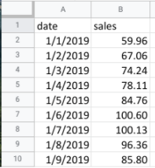

You can use this data to determine whether a specific date falls on a weekend or holiday and add a column to your sheet that reflects this information. Then, you can find out whether sales on the weekends and holidays are greater than sales on other days. This will be useful to know for inventory planning and marketing purposes.

### 

### **Question 4: How does profitability differ for new customers versus returning customers?**

Your dataset does not contain sales data related to new customers. Without this data, you won’t be able to answer your final question. However, it may be the case that the company collects customer data and stores it in a different data table.

If so, your next step would be to find out how to access the company’s customer data. You can then join the revenue sales data to the customer data table to categorize each sale as from a new or returning customer and analyze the difference in profitability between the two sets of customers. This information will help your stakeholders develop marketing campaigns for specific types of customers to increase brand loyalty and overall profitability.

## **Key takeaways**

When working on analytics projects, you won’t always have all the necessary or relevant data at your disposal. In many of these cases, you can turn to other data sources to fill in the gaps.

Despite the limitations of your dataset, it’s still possible to offer your stakeholders some valuable insights. For next steps, your best plan of action will be to take the initiative to ask questions, identify other relevant datasets, or do some research on your own. No matter what data you’re working with, carefully inspecting your data makes a big impact on the overall quality of your analysis.

[**TEST YOUR KNOWLEDGE ON WORKING WITH DATABASES**](https://www.coursera.org/learn/data-preparation/quiz/rz8nP/test-your-knowledge-on-working-with-databases)

**MANAGE DATA WITH METADATA**

[**DEMYSTIFY METADATA**](https://www.coursera.org/learn/data-preparation/lecture/vsFl7/demystify-metadata)

Now that you understand the different ways to organize data in a database, let's talk about **how** you can **describe** that **data**. In this video, we'll start exploring **metadata**, which is a very **important aspect** of **database management**.

**Metadata is an abstract concept**, though. Let's kick things off with a simple, everyday example. Did you know that every time a photo is taken with a smartphone, data is automatically collected and stored within that photo? Take a look. Choose any photo on your computer. Here's a cute shot of my friend's dogs, Rudy and Matilda. On your photo, right-click on "Get Info" or "Properties."

This will give you the **photo's metadata**, which may tell you the **type of file it is; the date and time it was taken; the geolocation, or where it was taken; what kind of device was used to take the photo; and much more**.

Another example. Every time you send or receive an email, metadata is sent right along with that message. You can find it by clicking on "Show Original" or "View Message Details." An email message's metadata includes its subject, who it's from, who it's to, and the date and time it was sent. The metadata even knows how quickly it was delivered after the sender pressed, "Send."

Metadata is information that's used to describe the data that's contained in something, like a photo or an email.

Keep in mind that metadata is not the data itself. Instead, it's data about the data. In data analytics, metadata **helps data analysts interpret the contents of the data within a database**. That's why metadata is so **important** when **working with databases**. It tells an analyst what the data is all about. That makes it possible to put the data to work solving problems and making data-driven decisions.

As a data analyst, there are **three common types of metadata** that you'll come across: **administrative**, **descriptive**, and **structural**.

**3 Common types of metadata: A D S**

**Administrative** metadata which is metadata that indicates the technical source of a digital asset.

When we looked at the metadata inside the photo, that was administrative metadata. It shows you the type of file it was, the date and time it was taken, and much more.

**Descriptive** metadata is metadata that describes a piece of data and can be used to identify it at a later point in time. For instance, the descriptive metadata of a book in a library would include the code you see on its spine, known as a unique International Standard Book Number, also called the ISBN. It would also include the book's author and title.

**Structural** metadata, which is metadata that indicates **how** a piece of data is organized and whether it's part of one or more than one data collection. Let's head back to the library. An example of structural data would be how the pages of a book are put together to create different chapters. It's important to note that structural metadata also keeps track of the relationship between two things. For example, it can show us that the digital document of a book manuscript was actually the original version of a now printed book.

**MORE EXAMPLES OF THE THREE TYPES OF METADATA:**

**Administrative metadata**

* File type of a digital document
* Date a digital document was created
* Date a digital document was last modified
* Author of a digital document
* Copyright information for a digital document

**Descriptive metadata**

* Title of a book
* Author of a book
* Date a book was published
* ISBN of a book
* Keywords associated with a book

**Structural metadata**

* Table of contents of a book
* Chapters of a book
* Sections of a book
* Relationships between different parts of a book

**Here's one final thought to help you understand metadata.** If you're on your way to the library to pick out a book, you could research a book's title, author, length, and number of chapters. That's all metadata, and it can tell you a lot about the book, but you have to actually read the book to know what it's all about.

Likewise, you can read about data analytics, but you have to take this course to earn the Google Data Analytics certificate. Keep moving forward to gain that new perspective.

[**METADATA IS AS IMPORTANT AS THE DATA ITSELF**](https://www.coursera.org/learn/data-preparation/supplement/mdF9p/metadata-is-as-important-as-the-data-itself)

Data analytics, by design, is a field that thrives on collecting and organizing data. In this reading, you’ll learn about metadata and the type of information it can provide. In addition, you’ll explore examples of metadata.



Explore a data file by opening any file on your computer or a document in your home or workplace. What is it? Where did it come from? Is it useful? How do you know? This is where metadata comes in to provide a deeper understanding of the data. To put it simply, **metadata** is data about data. In database management, metadata provides information about other data and helps data analysts interpret the contents of the data within a database.

Regardless of whether you’re working with a large or small quantity of data, metadata is the mark of a knowledgeable analytics team. Metadata helps people communicate about data across the business and makes it easier to reuse data. In essence, metadata **tells the who, what, when, where, which, why, and how of data**.

## **Elements of metadata**

Before examining metadata examples, it’s important to understand what type of information metadata typically provides:

* **File or document type:** What type of file or document are you examining?
* **Date, time, and creator:** When was it created? Who created it? When was it last modified?
* **Title and description:** What is the name of the item you are examining? What type of content does it contain?
* **Geolocation:** If you’re examining a photo, where was it taken?
* **Tags and categories:** What is the general overview of the item that you have? Is it indexed or described in a specific way?
* **Who last modified it and when:** Were any changes made to the file? If yes, when were the most recent modifications made?
* **Who can access or update it:** If you’re examining a dataset, is it public? Are special permissions needed to customize or modify it?

## **Examples of metadata**

In today’s digital world, metadata is everywhere! Here are some examples—with accompanying images—of where you might find metadata.

### **Photos**

Whenever a photo is captured with a camera, metadata such as filename, date, time, geolocation, and the type of device on which it was taken are gathered and saved with it. The metadata of the following photo is displayed as a pop-up alongside the photo.



Image with accompanying Information pop-up that displays its description, the date and time the image was taken, its size, the device on which it was taken, and an option to add the geolocation of the image.

### **Emails**

When an email is sent or received, it contains metadata such as subject line, sender, recipient, date sent, and time sent.



Emails also contain hidden metadata that includes server names, IP addresses, HTML format, and software details. This image includes hidden email metadata such as the message ID and when the email was created.

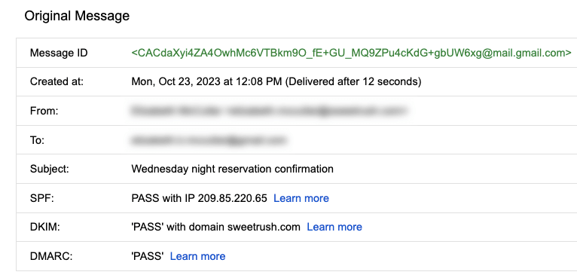

Hidden metadata from an email that includes Message ID, creation date, the recipient, the sender, the subject line, the SPF, DKIM, and DMARC.

### **Spreadsheets and electronically created documents**

Spreadsheets and documents are already filled with a considerable amount of data, so it’s no surprise that they also include metadata such as title, author, creation date, number of pages, and user comments. Additionally, spreadsheet metadata includes tab names, tables, and columns. In the following example, the image demonstrates the metadata for an electronically created Google Sheet:

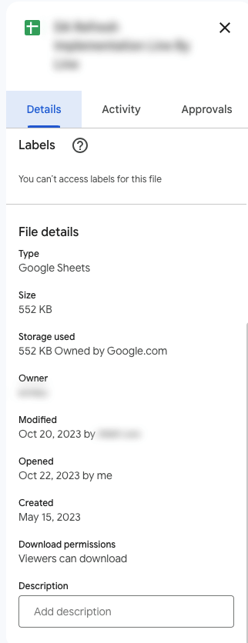

The metadata of a Google Sheet including the title, type, size, storage used, owner, the last person who modified the document, the last person who opened the document, when it was created, download permissions, and an option to include a description.

### **Websites**

Every web page has a number of standard metadata fields such as tags and categories, the site creator’s name, web page title and description, and time of creation. Results of search engine queries that you might make on a daily basis are metadata!



A search engine result that includes Meta title as Google Advanced Data Analytics Professional Certificate. Under the website hyperlink is the Meta description that says: Offered by Google. Learn in-demand skills like statistical analysis, Python, regression models, and machine learning in less than 6 months. Enroll for free.

### **Books and audiobooks**

Non-digital items can have metadata, too! Every book has standard metadata that will inform you of its title, author’s name, a table of contents, publisher information, copyright description, index, and a brief description of the book’s contents. Audiobook metadata also includes this data, as well as metadata specific to the audiobook such as narrator and recording length.



Audiobook’s metadata including the title of the audiobook, author, narrator, its length, the release date, language the audiobook is read in, its published, and its rating score.

## **Key takeaways**

Metadata can be found in photos, emails, spreadsheets, websites, and much more! In your daily life, you use metadata to stay organized. As a data analyst, you’ll **use metadata to understand** the **content** and **context** of your **data**, as well as **how it’s structured**. Metadata provides data analysts with information about a data’s file type, title, geolocation, who created it, who last modified it, and who has access to it. As a data analyst, it’s important to keep accurate records of metadata to ensure that you are able to find, use, preserve, and reuse data in the future. Remember, it will be your responsibility to manage and make use of data in its entirety; metadata is as important as the data itself.

[**METADATA AND METADATA REPOSITORIES**](https://www.coursera.org/learn/data-preparation/supplement/noiNb/metadata-and-metadata-repositories)

As you’re learning, metadata is data about data. It clearly describes how and when data was collected and how it’s organized. Metadata puts data into context and makes the data more understandable. This helps data analysts use data to solve problems and make informed business decisions.

In this reading, you’ll learn more about the benefits of metadata, metadata repositories, and metadata of external databases.

## **The benefits of metadata**

### **Reliability**

Data analysts use reliable and high-quality data to identify the root causes of any problems that might occur during analysis and to improve their results. If the data being used to solve a problem or to make a data-driven decision is unreliable, there’s a good chance the results will be unreliable as well.

Metadata helps data analysts confirm their data is reliable by making sure it is:

* Accurate
* Precise
* Relevant
* Timely

It does this by helping analysts ensure that they’re working with the right data and that the data is described correctly. For example, a data analyst completing a project with data from 2022 can use metadata to easily determine if they should use data from a particular file.

### **Consistency**

Data analysts thrive on consistency and aim for uniformity in their data and databases, and metadata helps make this possible. For example, to use survey data from two different sources, data analysts use metadata to make sure the same collection methods were applied in the survey so that both datasets can be compared reliably.

When a database is consistent, it’s easier to discover relationships between the data inside the database and data that exists elsewhere. When data is uniform, it is:

* Organized: Data analysts can easily find tables and files, monitor the creation and alteration of assets, and store metadata.
* Classified: Data analysts can categorize data when it follows a consistent format, which is beneficial in cleaning and processing data.
* Stored: Consistent and uniform data can be efficiently stored in various data repositories. This streamlines storage management tasks such as managing a database.
* Accessed: Users, applications, and systems can efficiently locate and use data.

Together, these benefits empower data analysts to effectively analyze and interpret their data.

## **Metadata repositories**

Metadata repositories help data analysts ensure their data is reliable and consistent.

Metadata repositories are specialized databases specifically created to store and manage metadata. They can be kept in a physical location or a virtual environment—like data that exists in the cloud.

Metadata repositories describe where the metadata came from and store that data in an accessible form with a common structure. This provides data analysts with quick and easy access to the data. If data analysts didn’t use a metadata repository, they would have to select each file to look up its information and compare the data manually, which would waste a lot of time and effort.

Data analysts also use metadata repositories to bring together multiple sources for data analysis. Metadata repositories do this by describing the state and location of the data, the structure of the tables inside the data, and who accessed the user logs.

## **Metadata of external databases**

Data analysts use both second-party and third-party data to gain valuable insights and make strategic, data-driven decisions. Second-party data is data that’s collected by a group directly from the group’s audience and then sold. Third-party data is provided by outside sources that didn’t collect it directly. The providers of this data are not its original collectors and do not have a direct relationship with any individuals to whom the data belongs. The outside providers get the data from websites or other programs that pull it from the various platforms where it was originally generated.

Data analysts should understand the metadata of external databases to confirm that it is consistent and reliable. In some cases, they should also contact the owner of the third-party data to confirm that it is accessible and available for purchase. Confirming that the data is reliable and that the proper permissions to use it have been obtained are best practices when using data that comes from another organization.

## **Key takeaways**

Metadata helps data analysts make data-driven decisions more quickly and efficiently. It also ensures that data and databases are reliable and consistent.

Metadata repositories are used to store metadata—including data from second-party and third-party companies. These repositories describe the state and location of the metadata, the structure of the tables inside it, and who has accessed the repository. Data analysts use metadata repositories to ensure that they use the right data appropriately.

[**MANAGE DATA WITH METADATA**](https://www.coursera.org/learn/data-preparation/lecture/C7QQB/manage-data-with-metadata)

a

[**MEGAN: FUN WITH METADATA**](https://www.coursera.org/learn/data-preparation/lecture/bHqPA/megan-fun-with-metadata)

a

[**TEST YOUR KNOWLEDGE ON METADATA**](https://www.coursera.org/learn/data-preparation/quiz/gIn3V/test-your-knowledge-on-metadata)

a

**ACCESS DIFFERENT DATA SOURCES**

[**SO MANY PLACES TO FIND DATA**](https://www.coursera.org/learn/data-preparation/lecture/jj7B1/so-many-places-to-find-data)

a

[**STEP-BY-STEP: IMPORT DATA FROM SPREADSHEETS AND DATABASES**](https://www.coursera.org/learn/data-preparation/supplement/esVz6/step-by-step-import-data-from-spreadsheets-and-databases)

a

[**IMPORT DATA FROM SPREADSHEETS AND DATABASES**](https://www.coursera.org/learn/data-preparation/lecture/KCphN/import-data-from-spreadsheets-and-databases)

a

[**IMPORT DATA DYNAMICALLY**](https://www.coursera.org/learn/data-preparation/supplement/2slzg/import-data-dynamically)

a

[**EXPLORE PUBLIC DATASETS**](https://www.coursera.org/learn/data-preparation/supplement/8yrhM/explore-public-datasets)

a

[**TEST YOUR KNOWLEDGE ON ACCESSING DATA SOURCES**](https://www.coursera.org/learn/data-preparation/quiz/2fOBQ/test-your-knowledge-on-accessing-data-sources)

a

**SORT AND FILTER DATA**

[**SORT AND FILTER TO FOCUS ON RELEVANT DATA**](https://www.coursera.org/learn/data-preparation/lecture/LUq19/sort-and-filter-to-focus-on-relevant-data)

a

[**HANDS-ON ACTIVITY: CLEAN DATA IN SPREADSHEETS WITH SORTING AND FILTERING**](https://www.coursera.org/learn/data-preparation/quiz/JY3Zv/hands-on-activity-clean-data-in-spreadsheets-with-sorting-and-filtering)

a

[**SELF-REFLECTION: COMPARE DATABASES AND SPREADSHEETS**](https://www.coursera.org/learn/data-preparation/quiz/a1ShE/self-reflection-compare-databases-and-spreadsheets)

a

[**TEST YOUR KNOWLEDGE ON SORTING AND FILTERING**](https://www.coursera.org/learn/data-preparation/quiz/HKePv/test-your-knowledge-on-sorting-and-filtering)

a

**LARGE DATASETS IN SQL**

[**GET TO KNOW BIGQUERY, WITH SANDBOX AND BILLING OPTIONS**](https://www.coursera.org/learn/data-preparation/lecture/YCkys/get-to-know-bigquery-including-sandbox-and-billing-options)

a

[**SET UP YOUR BIGQUERY ACCOUNT**](https://www.coursera.org/learn/data-preparation/supplement/DYOQK/set-up-your-bigquery-account)

a

[**GET STARTED WITH BIGQUERY**](https://www.coursera.org/learn/data-preparation/supplement/7ctZ8/get-started-with-bigquery)

a

[**STEP-BY-STEP: BIGQUERY IN ACTION**](https://www.coursera.org/learn/data-preparation/supplement/PZ6Sv/step-by-step-bigquery-in-action)

a

[**BIGQUERY IN ACTION**](https://www.coursera.org/learn/data-preparation/lecture/H877e/bigquery-in-action)

a

[**HANDS-ON ACTIVITY: INTRODUCTION TO BIGQUERY**](https://www.coursera.org/learn/data-preparation/quiz/OsfsT/hands-on-activity-introduction-to-bigquery)

a

[**HANDS-ON ACTIVITY: CHOOSE THE RIGHT TOOL FOR THE JOB**](https://www.coursera.org/learn/data-preparation/quiz/KThkt/hands-on-activity-choose-the-right-tool-for-the-job)

a

[**HANDS-ON ACTIVITY: MORE PRACTICE WITH SQL**](https://www.coursera.org/learn/data-preparation/quiz/vGN91/hands-on-activity-more-practice-with-sql)

a

[**TEST YOUR KNOWLEDGE ON USING SQL WITH LARGE DATASETS**](https://www.coursera.org/learn/data-preparation/quiz/3UyRx/test-your-knowledge-on-using-sql-with-large-datasets)

a

**MODULE 3 CHALLENGE**

[**GLOSSARY TERMS FROM MODULE 3**](https://www.coursera.org/learn/data-preparation/supplement/MOjTP/glossary-terms-from-module-3)

a

**MODULE 4- ORGANIZE AND PROTECT DATA**

**BRING DATA TO ORDER**

[**CHALLENGE**](https://www.coursera.org/learn/data-preparation/exam/jZOOG/module-2-challenge)

**SECURE DATA**

**MODULE 4 CHALLENGE**

**MODULE 5- ENGAGE IN DATA COMMUNITY**

**CREATE OR ENHANCE YOUR ONLINE PRESENCE**

[**CHALLENGE**](https://www.coursera.org/learn/data-preparation/exam/jZOOG/module-2-challenge)

**BUILD A DATA ANALYTICS NETWORK**

**COURSE WRAP-UP**

**Stakeholders** are people that have invested time, interest, and resources into the projects that you'll be working on as a data analyst. In other words, **they hold stakes in what you're doing.** There's a good chance they'll need the work you do to perform their own needs.